
Asia Pacific University of Technology & Innovation
Technology Park Malaysia
CT038-3-2-OODJ
Object Oriented Development with Java
Intake Code: NPT2F2511IT

Group Name : A12_Group_G
Hand Out Date : 12th December, 2025
Hand in Date : 14th March, 2026
Weightage : 50%

Members | APU ID
Rabin Bista | NP070294
Aakash Subedi | NP070062
Abdul Rahman Kawari | NP070082
Mimi Shrestha | NP070232

Acknowledgement
We would like to thank our module lecturer who helped and assisted in this assignment. Their comments and training actually assisted in developing the design and execution of the Hall Booking Management System.
We are grateful to the Asia Pacific University of Technology and Innovation (APU) which provided the necessary resources, and a favorable learning environment that contributed to the completion of this project by us successfully. Lastly, there is the appraisal of the efforts and commitment of the whole team members to the collaboration and dedication of the task of accomplishing the assignment unitedly.

Table of Contents
List of Figures 1
Introduction 3
Design Solutions 4
Use-Case Diagram 4
Class Diagram 5
Description and Justification of OOP Principles 6
Encapsulation 6
Inheritance 8
Polymorphism 10
Abstraction 12
Program Output Screenshots 15
Login and Registration 15
Administrator 16
Manager 19
Scheduler 21
Customer 24
Additional Features 29
Limitations and Conclusion 30
Limitations 30
Conclusion 30
References 31
Appendix – Text File Screenshots 32
Appendix A - users.txt 32
Appendix B - halls.txt 32
Appendix C - bookings.txt 33
Appendix D - payments.txt 33
Appendix E - issues.txt 34

List of Figures
Figure 1: Use-Case Diagram 4
Figure 2: Class Diagram 12
Figure 3: User.java: Encapsulation 14
Figure 4: User.java 2: Encapsulation 15
Figure 5: Booking.java: Encapsulation 15
Figure 6: Issue.java 1: Encapsulation 16
Figure 7: Issue.java 2: Encapsulation 16
Figure 8: 16
Figure 9: Customer.java: Inheritance 17
Figure 10: Scheduler.java: Inheritance 17
Figure 11: Administrator.java: Inheritance 18
Figure 12: Manager.java: Inheritance 18
Figure 13: FileManager.java: Inheritance 18
Figure 14: User.java: Polymorphism 19
Figure 15: Customer.java: Polymorphism 19
Figure 16: Scheduler.java: Polymorphism 19
Figure 17: Administrator.java: Polymorphism 19
Figure 18: Manager.java: Polymorphism 20
Figure 19: LoginFrame.java: Polymorphism 20
Figure 20: User.java: Abstraction 21
Figure 21: FileManager.java 1: Abstraction 21
Figure 22: FileManager.java 2: Abstraction 21
Figure 23: FileManager.java 3: Abstraction 22
Figure 24: Login Page 23
Figure 25: Registration Page 23
Figure 26: Admin Dashboard 24
Figure 27: Adding Scheduler Account 25
Figure 28: View/Manage Schedulers 25
Figure 29: View/Manage Customers 26
Figure 30: View All Bookings 26
Figure 31: Generate Booking Report 27
Figure 32: Manager Dashboard 27
Figure 33: View Sales Dashboard 28
Figure 34: View and Manage Issue 28
Figure 35: Scheduler Dashboard 29
Figure 36: Manage Halls 30
Figure 37: View All Halls 30
Figure 38: Set Hall Availability 31
Figure 39: View All Booking 31
Figure 40: View Assigned Issues 32
Figure 41: Customer Dashboard 32
Figure 42: View Available Halls 33
Figure 43: Book a Hall 33
Figure 44: View Booking History 34
Figure 45: Make Payments 35
Figure 46: Raise Issue 35
Figure 47: Update Profile 36
Figure 48: User.txt 40
Figure 49: Halls.txt 40
Figure 50: Bookings.txt 41
Figure 51: Payments.txt 41
Figure 52: Issue.txt 42

Introduction
The Hall Booking Management System is a Java desktop GUI application that was created by Hall Symphony Inc. The system supports four user roles, namely Scheduler, Customer, Administrator, Manager, and each possesses different dashboards and capabilities associated with each. Java Swing is used to build the GUI and the storage and retrieval of data through plain text files in CSV format, as required by the project.
Hall Symphony Inc serves three types of halls namely; Auditorium, Banquet Hall, and Meeting Rooms with seats of 1,000, 300 and 30 respectively, respectively. The halls are open all days and time 8:00 AM-6:00 PM. The report entails the specifications of the UML design diagrams, OOP concepts used, program outputs snapshots, and other features, restrictions, and conclusion.

Design Solutions

Use-Case Diagram
Figure 1:
Use-Case Diagram
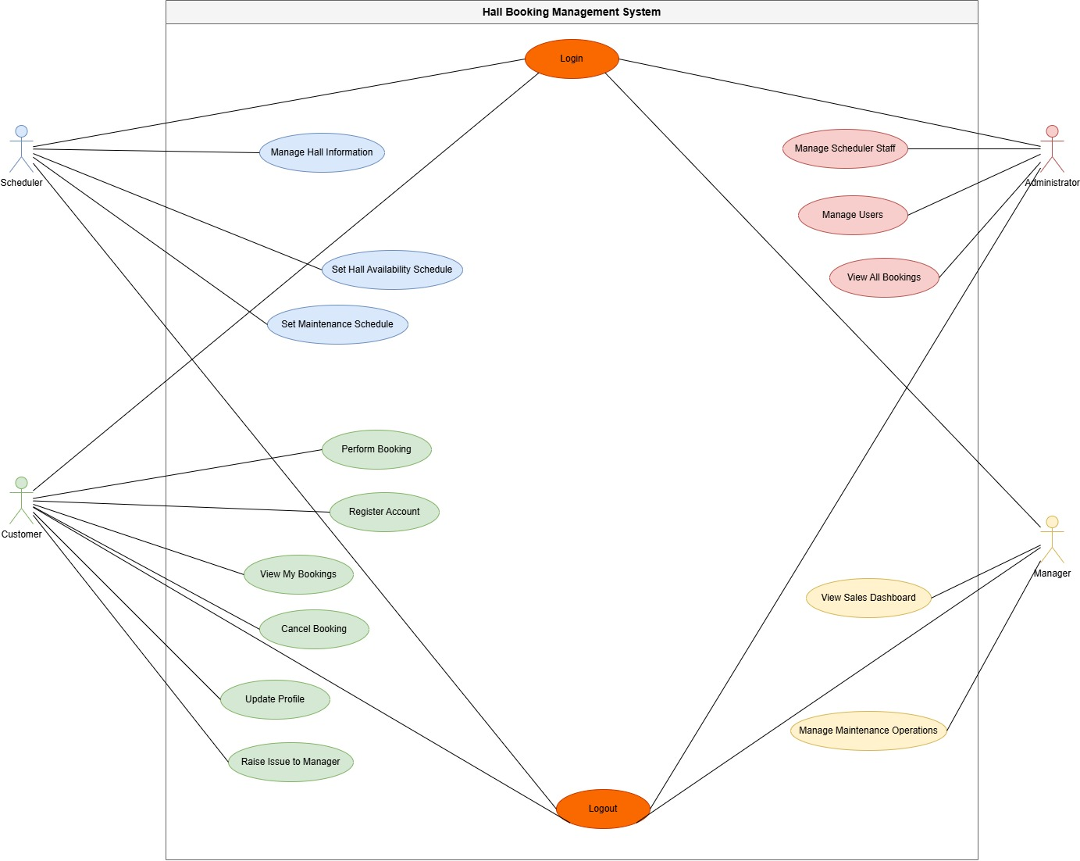
The above diagram depicts a use case for interactions between the four actors and the system. Among other things, the Scheduler has to monitor hall records, set hall availability schedules, and set maintenance schedules (Bloch, 2018). Conversely, a Customer will have to register an account, log in to the system, make bookings by selecting a hall and proceeding to payment view the payment receipt, booking history, cancel bookings for at least three days before the event date, update their profile, and raise issues to the Manager. This will include the Administrator; who:
- Leads Scheduler accounts: add, view, filter, edit, delete.
- Customer accounts: view, filter, block/delete. This is a manager that views all bookings.
- Sales dashboard view by the Manager for periods weekly, monthly, and yearly. He has the ability to view and manage maintenance operations through the view of customer issues and their response, then assignment to a Scheduler to fix the issue at hand and changing issue status.
Use Case | Actor(s) | Pre-Condition | Main Flow | Alternative Flow | Post-Condition
Login | Scheduler, Customer, Administrator, Manager | Actor must hold a valid registered account | Actor submits credentials on the login screen; system verifies them and loads the appropriate role-based dashboard | Incorrect or empty credentials trigger an error notification prompting the actor to retry | Actor gains authenticated access to their designated system interface
Logout | Scheduler, Customer, Administrator, Manager | Actor must be actively logged into the system | Actor selects the logout option; system closes the session and redirects to the login page | Prolonged inactivity causes the system to auto-terminate the session and display a timeout alert | Session ends and all role-specific system access is revoked
Register Account | Customer | Customer must not already have an account in the system | Customer fills out the registration form with name, email, phone, and password then submits; system validates and stores the new account | Blank fields, invalid formats, or a duplicate email cause the system to display a specific error and request correction | A new customer account is created and the customer may now log in
Perform Booking | Customer | Customer must be logged in and an available hall must exist | Customer selects a hall, chooses a date and time slot, and confirms; system saves the reservation and marks the slot as occupied | If the chosen slot is taken, the system alerts the customer and presents alternative available options | Booking is confirmed and the hall slot is reserved under the customer's account
View My Bookings | Customer | Customer must be logged in | Customer opens the bookings section; system fetches and displays all reservations tied to their account including hall, date, and status | If no bookings are found, the system shows a message indicating no records exist | Customer can review their complete booking history
Cancel Booking | Customer | Customer must be logged in with at least one active upcoming booking | Customer selects a reservation and confirms cancellation; system updates the status to cancelled and releases the time slot | If the booking date has passed or cancellation is restricted, the system displays an ineligibility message | Booking is cancelled and the previously held hall slot is made available again
Update Profile | Customer | Customer must be logged in with an existing account | Customer navigates to profile settings, modifies the desired fields, and saves; system validates and stores the new information | Invalid inputs such as a duplicate email or weak password prompt the system to flag errors and request corrections | Customer profile is successfully updated across the system
Raise Issue to Manager | Customer | Customer must be logged in | Customer navigates to the issue section, enters a subject and description, and submits; system logs the issue and notifies the Manager | Incomplete or blank fields prompt the system to require all mandatory information before the form can be submitted | Issue is recorded in the system and the Manager is alerted for follow-up
Manage Hall Information | Scheduler | Scheduler must be logged in with appropriate privileges | Scheduler opens the hall management section, enters or updates hall details such as name, capacity, and facilities, then saves; system updates the records | Missing required fields or duplicate hall names cause the system to raise a validation error | Hall information is updated and reflected across the booking system
Set Hall Availability Schedule | Scheduler | Scheduler must be logged in and the target hall must exist in the system | Scheduler selects a hall, defines available dates and time slots, and confirms; system marks those slots as open for booking | Overlap with an existing maintenance period triggers a conflict warning requiring the Scheduler to resolve it | Hall availability is updated and customers can book within the newly defined slots
Set Maintenance Schedule | Scheduler | Scheduler must be logged in and the target hall must be registered | Scheduler picks a hall, specifies maintenance start and end times, and saves; system blocks those periods from customer reservations | Conflict with an active booking prompts the system to notify the Scheduler and request resolution before saving | The hall is marked unavailable during the maintenance window
Manage Scheduler Staff | Administrator | Administrator must be logged in with full administrative privileges | Administrator accesses the staff management panel, performs the required action such as adding, editing, or removing a Scheduler account, and confirms; system updates records accordingly | Duplicate entries or invalid data submitted during the process trigger a validation error | Scheduler staff account is successfully created, modified, or removed from the system
Manage Users | Administrator | Administrator must be logged in with full system access | Administrator searches for a user, selects them, and applies the desired action such as editing details or changing account status; system applies changes instantly | Attempting to deactivate a user with active bookings causes the system to issue a warning before the action proceeds | The selected user account is updated, activated, or deactivated as instructed
View All Bookings | Administrator | Administrator must be logged in | Administrator opens the bookings overview; system retrieves all system-wide reservations displaying customer, hall, date, time, and status with search and filter support | If no bookings exist in the system, a message is shown indicating no records are available | Administrator has full visibility over every booking across the entire system
View Sales Dashboard | Manager | Manager must be logged in and relevant booking or sales data must be present | Manager opens the sales dashboard; system compiles and presents visual reports covering revenue, booking volumes, and hall utilisation metrics | If no data exists for the selected period, the system notifies the Manager of insufficient data to render the report | Manager receives a current overview of the system's financial and operational performance
Manage Maintenance Operations | Manager | Manager must be logged in and at least one maintenance task must be scheduled | Manager reviews active and upcoming maintenance tasks, assigns responsibilities, and updates task statuses as work is completed | If a task remains incomplete beyond its scheduled end time, the system flags it and sends an overdue alert to the Manager | All maintenance operations are current and halls are confirmed ready to return to service on schedule

Class Diagram
Figure 2:
Class Diagram
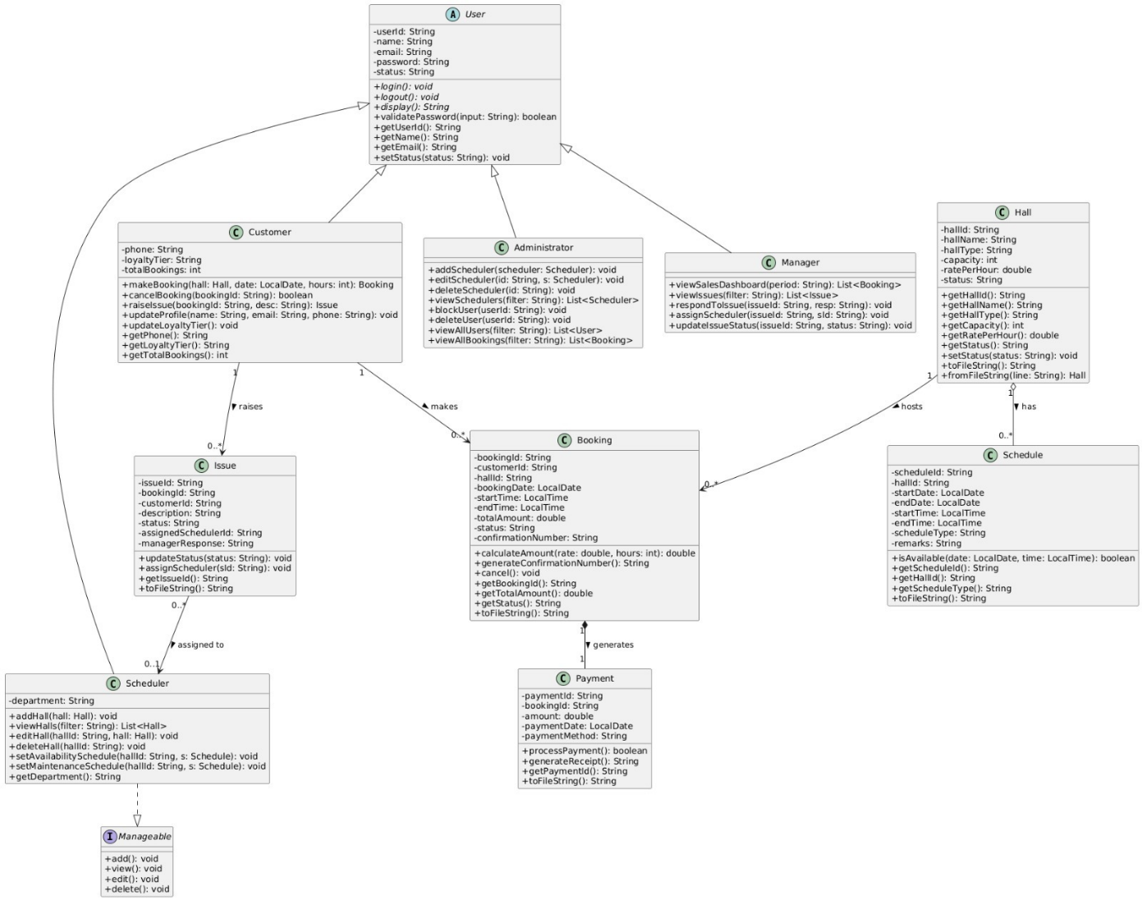
The above Class Diagram gives the overall model of the Model Layer of the system. It begins with an abstract User class which in turn is inherited by Customer, Scheduler, Administrator and Manager. Classes refer to the core business objects and have been modeled as Hall, Booking, Payment, Issue and Schedule. Util package contains the utility class of file I/O called FileManager which is used in all the GUI classes (Deitel & Deitel, Harvey, 2020).
The key associations among classes are: With the exception that, Customer, Scheduler, Administrator and Manager are derived from a User. A Booking can have a Customer record (one-to-many) and a Hall can be home to the record entries of many Bookings (one-to-many). There will be one Booking that produces one Payment. A Customer (zero-to-many) raises an Issue in an Issue given to Scheduler (zero-to-one). In the case of Halls, Schedule records are maintained on availability and maintenance problems (Oracle Corporation, 2024).

Description and Justification of OOP Principles

Encapsulation
Encapsulation is a method of object-oriented programming in which the data is concealed in an object by making the fields in an object as private. It will only display what is needed by the user (geeksforgeeks, 2026).
Code implementation:
From User.java:
Figure 3:
User.java: Encapsulation
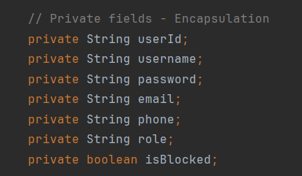
Figure 4:
User.java 2: Encapsulation
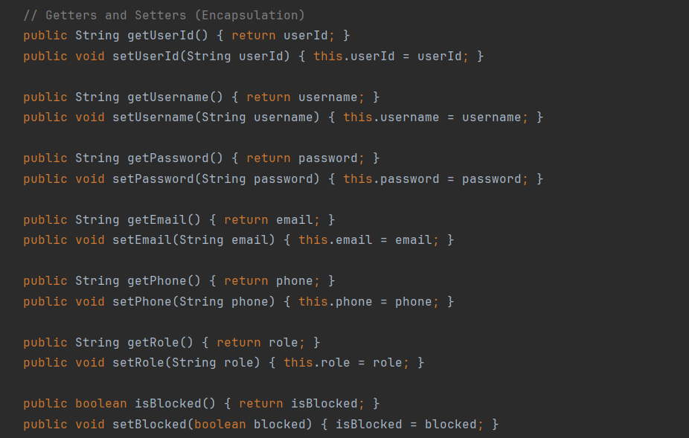
Figure 5:
Booking.java: Encapsulation
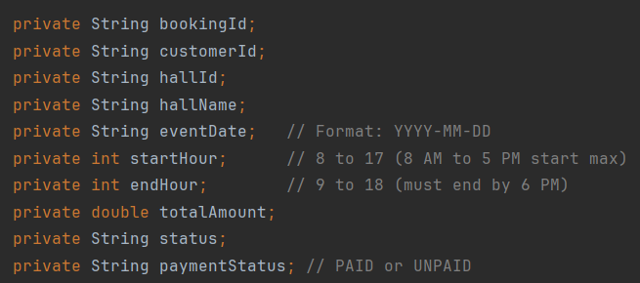
Figure 6:
Issue.java 1: Encapsulation
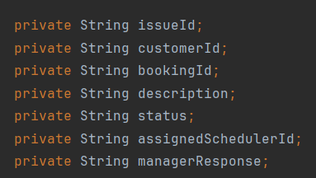
Figure 7:
Issue.java 2: Encapsulation
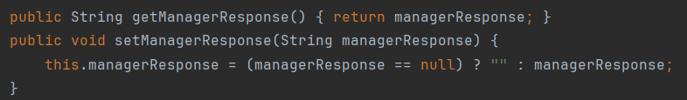
Figure 8:
FileManager.java 1: Encapsulation
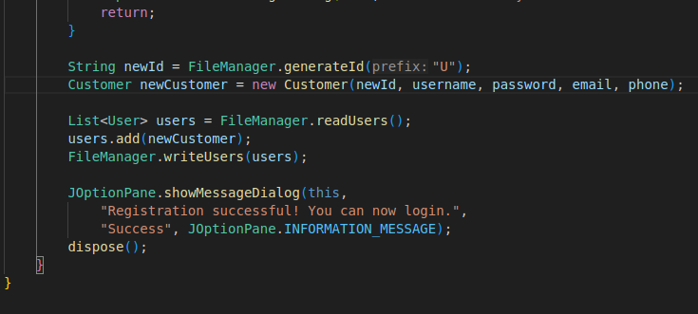
Justification:
This will ensure that important data like user passwords and financial values booked may not be changed as they please out of scope of the course. As an example, customerPassword must not be exposed or altered, and therefore, getPassword and setPassword functions have been developed. There is even a null-check of setManagerResponse() setter which demonstrates that a setter is far more ambitious to enforce data rules than a direct assignment of a field ever would be. This is what ensures the integrity of the data even when overall.txt file functions controlled by the FileManager.

Inheritance
Java Inheritance Let a subclass inherits characteristics and methods of superclass instance and allows us to establish the is-a relationship and promotes code Reusability (geeksforgeeks, 2026).
Figure 9:
Customer.java: Inheritance
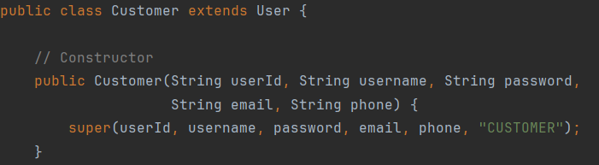
Figure 10:
Scheduler.java: Inheritance
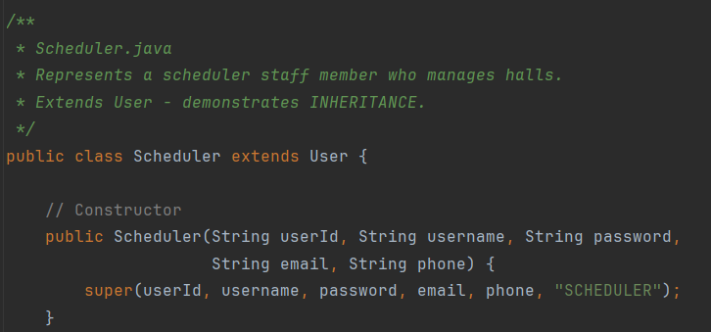
Figure 11:
Administrator.java: Inheritance
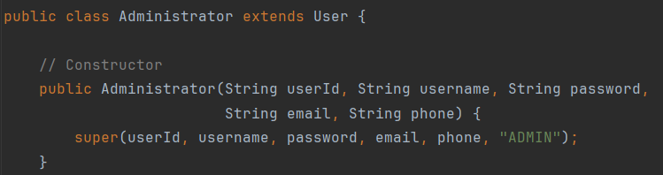
Figure 12:
Manager.java: Inheritance
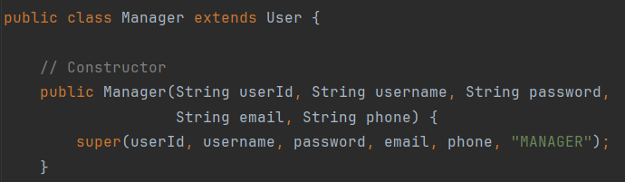
Figure 13:
FileManager.java: Inheritance
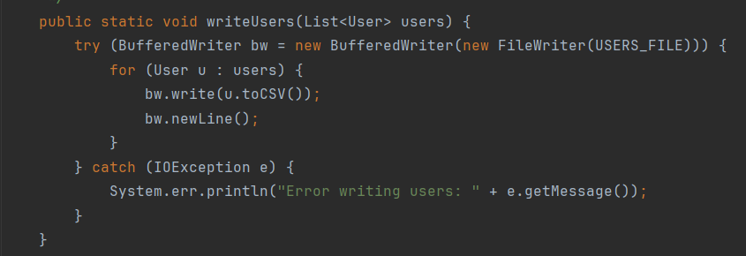
Justification
Having no inheritance, every single field and method shared by all users, including their credentials to log in and their block status in a CSV serialization to toCSV, would need to be copied in all four classes of users. In this regard, succession eliminates us of this redundancy. In this way, it allows file manager to iterate writeUsers() of a List<User> and invoke toCSV() of any user without any worry of the role that a user actually has because all subclasses implement the method of User.

Polymorphism
It allows the same method to be called (overridden) differently at run time since the native object is type-dependent , it may also help in implementing polymorphic behavior (geeksforgeeks, 2026).
Figure 14:
User.java: Polymorphism
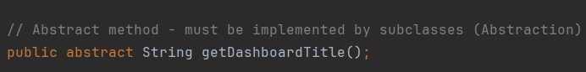
Figure 15:
Customer.java: Polymorphism
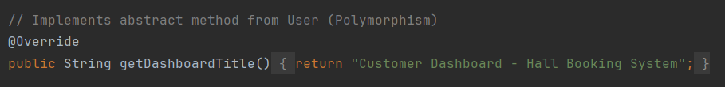
Figure 16:
Scheduler.java: Polymorphism
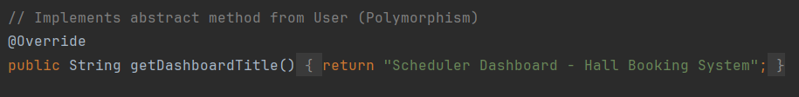
Figure 17:
Administrator.java: Polymorphism
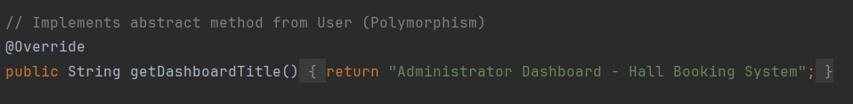
Figure 18:
Manager.java: Polymorphism
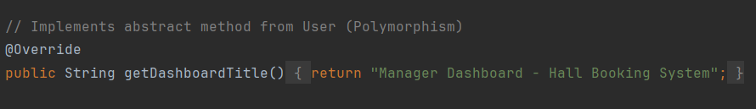
Figure 19:
LoginFrame.java: Polymorphism
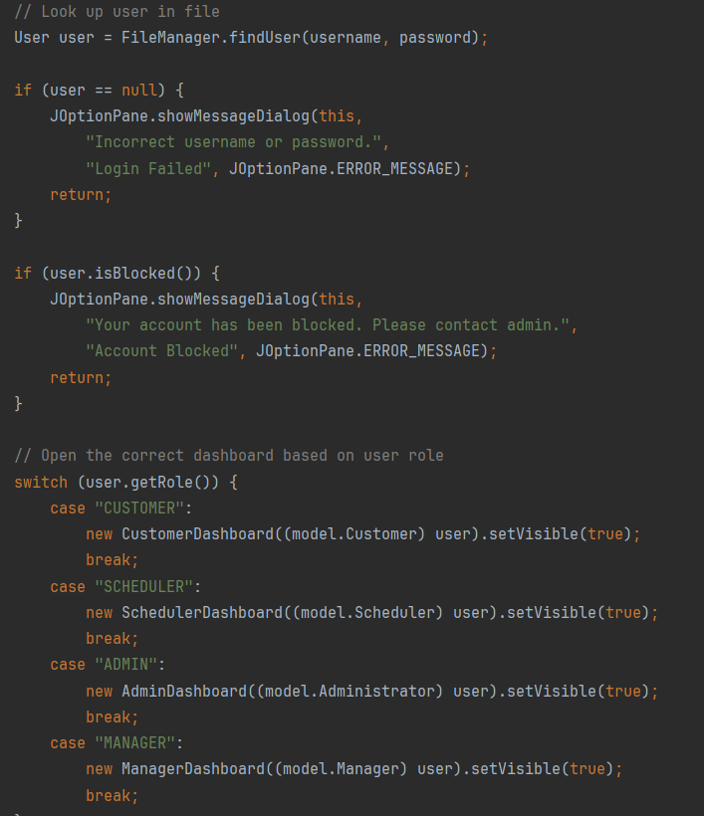
Justification:
With the application of polymorphism in this case, the login system is able to handle a single User reference without being aware of the type it is until runtime. The isBlocked method and the getRole method will continue their normal operation regardless of the type of job object it is a Customer, Scheduler, Administrator, or Manager object. With a new role that is added tomorrow, then we just need to add on that with an overriding getDashboardTitle() method in a new subclass and a new case to the switch statement, but the rest of the logic in the login would be the same.

Abstraction
This lets one hide away all of the trivial implementation details showing only the exposed part, which is relevant to the outside world. It is achieved by means of the abstract User class and utility class FileManager (geeksforgeeks, 2026).
Figure 20:
User.java: Abstraction
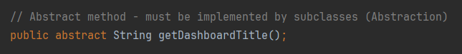
Figure 21:
FileManager.java 1: Abstraction
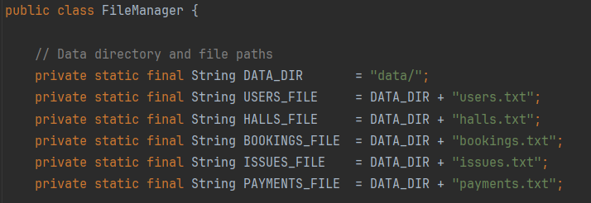
Figure 22:
FileManager.java 2: Abstraction
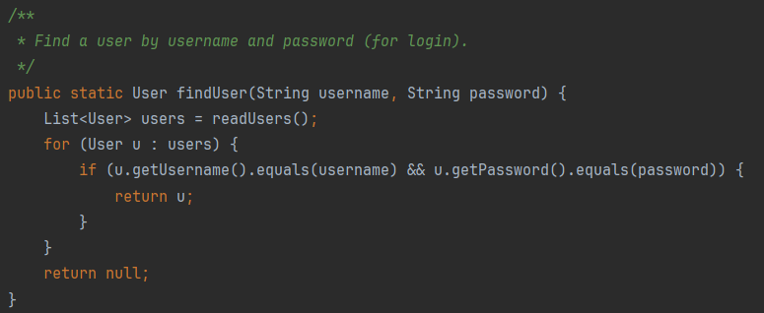
Figure 23:
FileManager.java 3: Abstraction
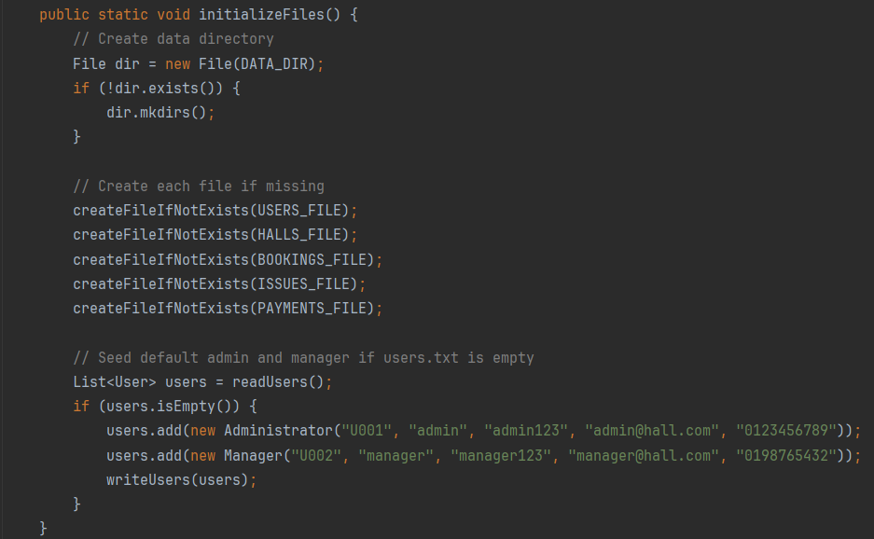
Justification:
This provides an abstract class, User that will specify the contract in each type of user may implement getDashboardTitle but the arrangement of the internal fields to external classes is concealed. User is not directly instantiated, and it is a matter of ensuring that there is always a concrete role-specific subclass in the system, among all the user objects. The data layer is abstracted in the FileManager class; the GUI classes CustomerDashboard and AdminDashboard only know it as a common interface in case it is reading or writing to a file. Had we needed to swap the process of data storage via .txt files into a database, then it is only FileManager that would have to be rewritten, as opposed to every GUI class being struck with the change.
Classes and Objects
A class is a diagram outlining the format and demeanour of an object. A real example of that class that was made during a run with real data is an object. Each model class in the Hall Booking management system reflects an actual object in the system.
There are six model classes used in the system: User, Customer, Scheduler, Administrator, Manager, Hall, Booking and Issue. All these happen to be templates. Upon the execution of the program, the classes are instantiated with objects using real values to depict real objects like a particular customer, a particular hall or a particular booking.
Figure 24
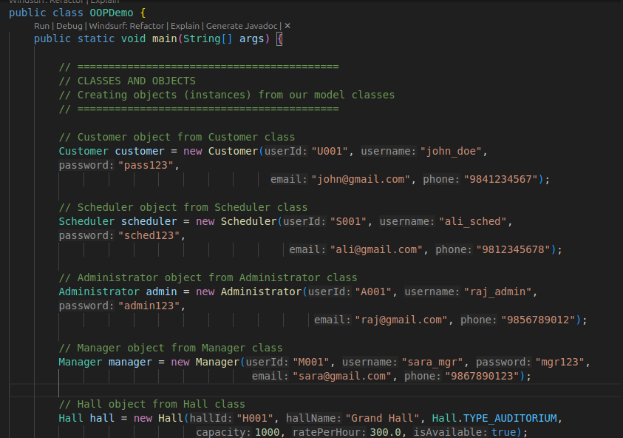
Figure

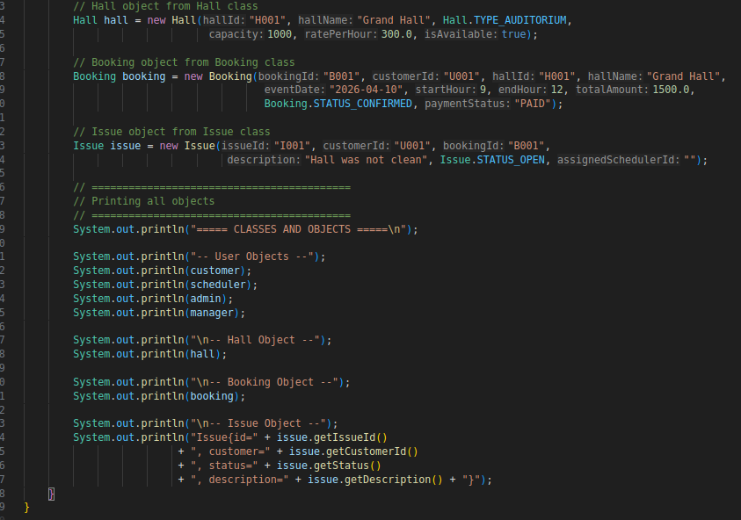
Justification:
All components in the system are dependent on objects being instantiated using these classes. Customer objects are created and stored when a customer is registered. On making a reservation, a Booking object is formed. On raising a complaint, an Issue object is generated. A Hall object is created when a scheduler is adding a venue.
None of these entities in the real-world can exist in the system without classes as blueprints. This ascertains that the system has a strong object based foundation that relies on classes with structure and objects that hold actual data onto which the system works on.

Program Output Screenshots

Login and Registration
Figure 24:
Login Page
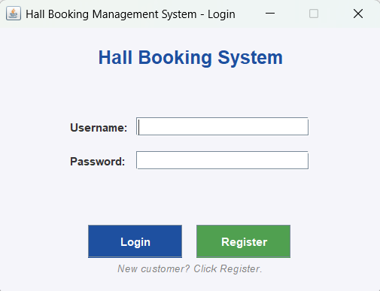
The default starting point of all the four user roles is the login screen. Here, the users need to input their username and password fields for authentication.
Figure 25:
Registration Page
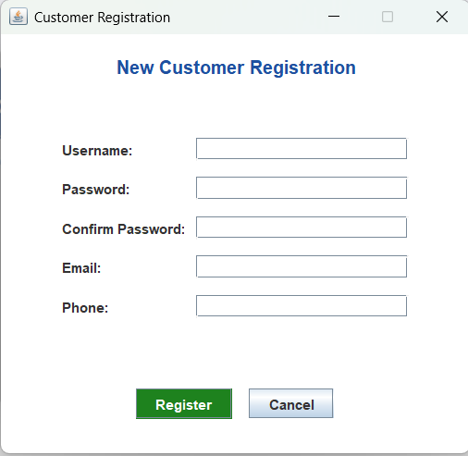
New customers will be able to register an account by filling in all their details at the registration screen. The system will validate all their fields and check for duplicate usernames before creating an account and saving it into users.txt.

Administrator
Figure 26:
Admin Dashboard
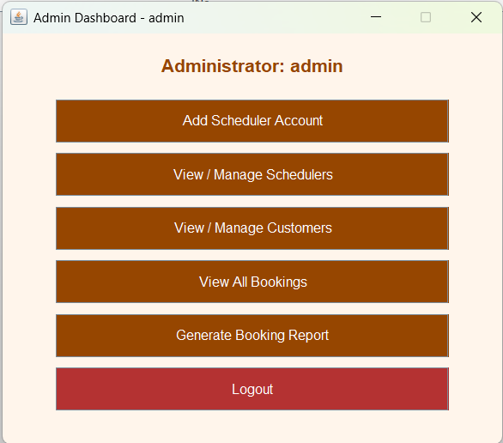
The management of the admin side is centered on the administrator dashboard. It also has access to scheduler management, user management, booking overviews, and report generations.
Figure 27:
Adding Scheduler Account
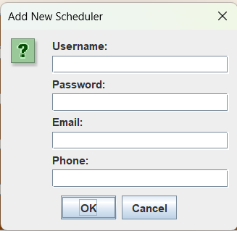
An admin has an ability to create a new Scheduler staff account by entering a username, password, email address, and phone number. Before saving to the system, it checks for duplicate usernames for the new account.
Figure 28:
View/Manage Schedulers
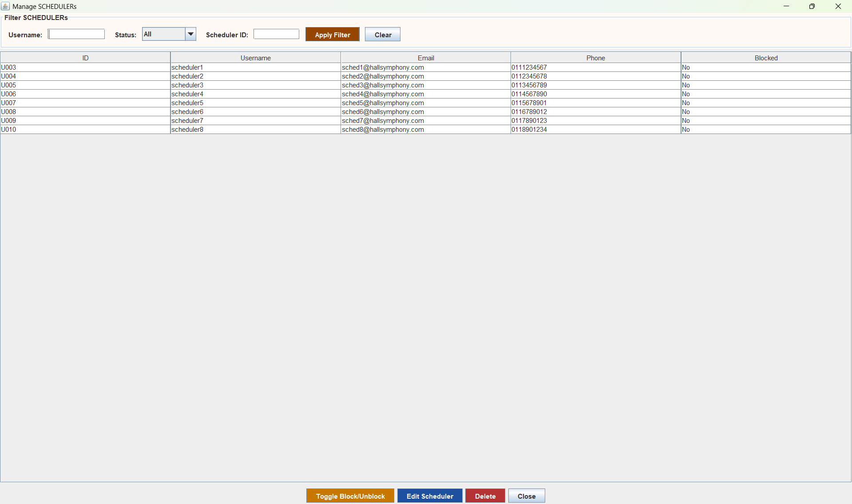
Displays a table of all Scheduler accounts which can be filtered. The administrator can select and block, unblock, or delete the Scheduler account from the system.
Figure 29:
View/Manage Customers
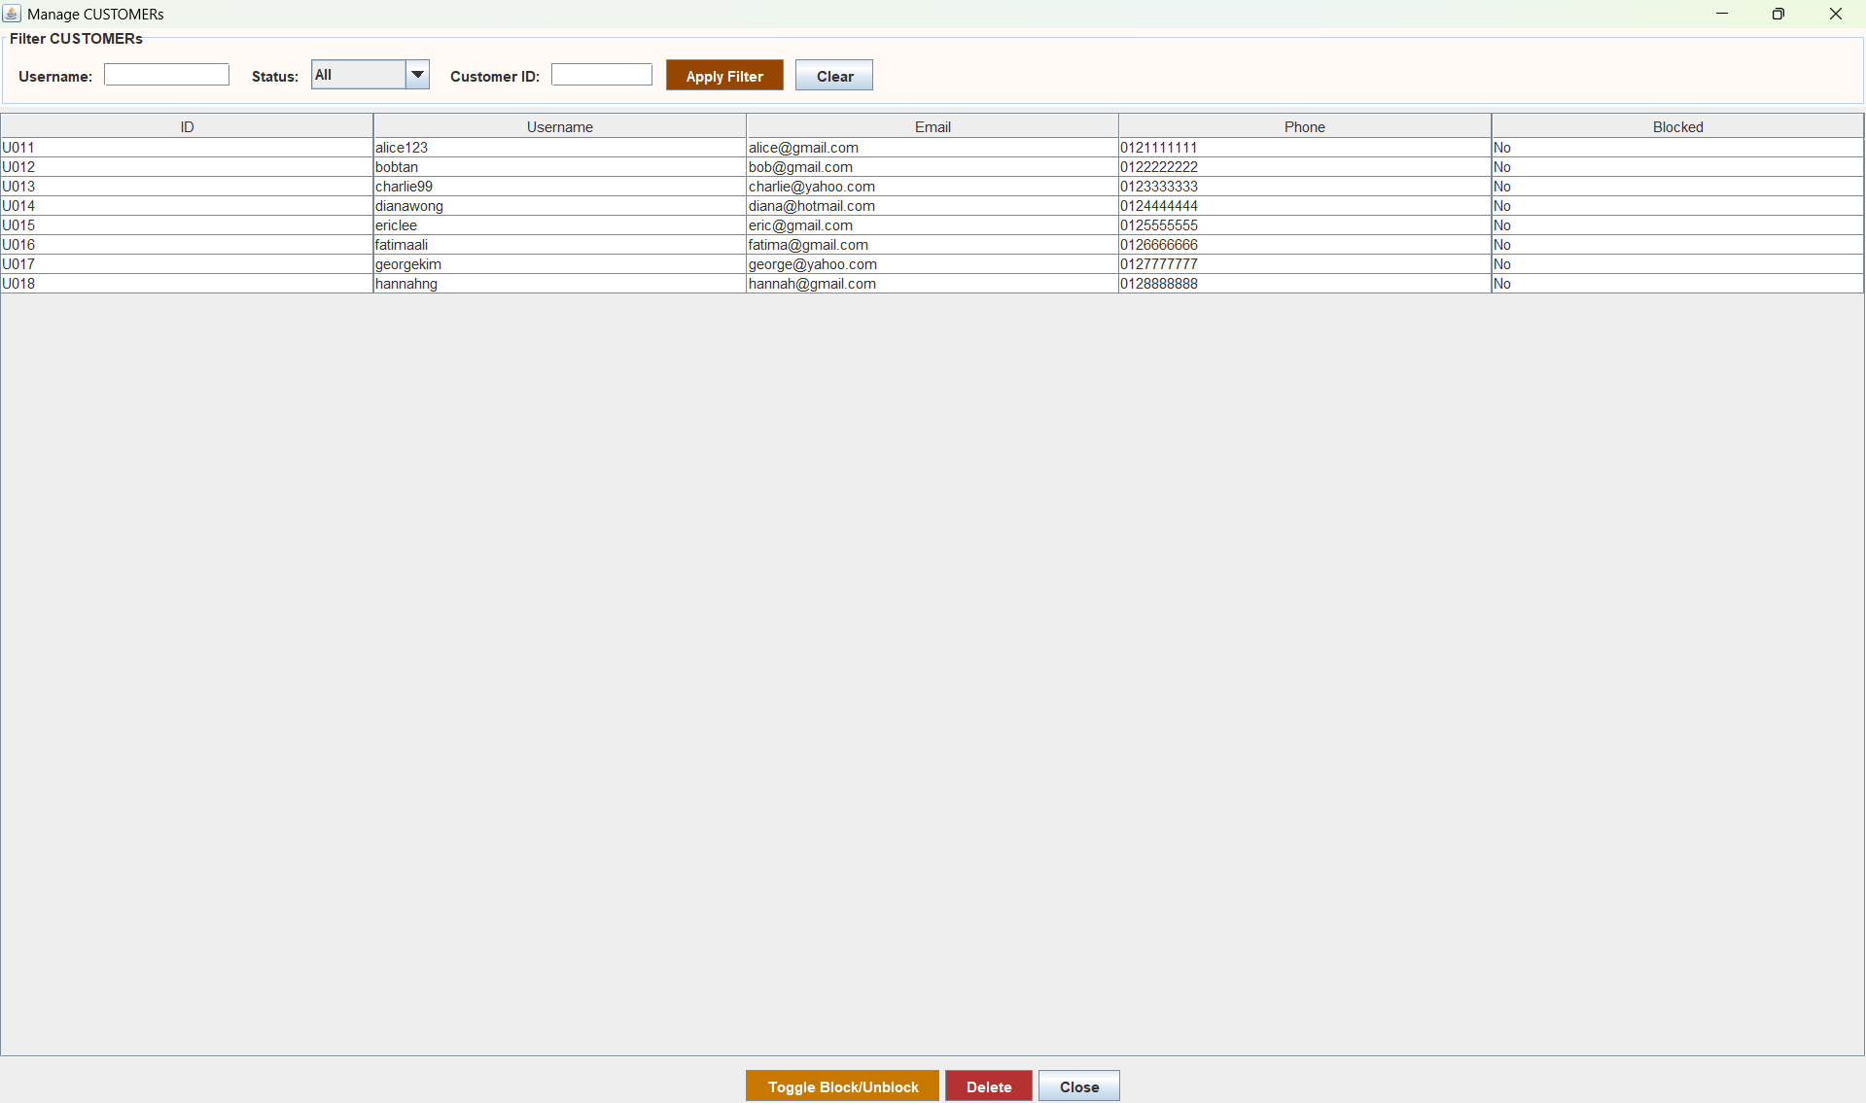
Shows a table of all customer accounts which are registered and are filterable. The administrator selects an account and blocks/unblocks or deletes it as per the requirement from the customer.
Figure 30:
View All Bookings
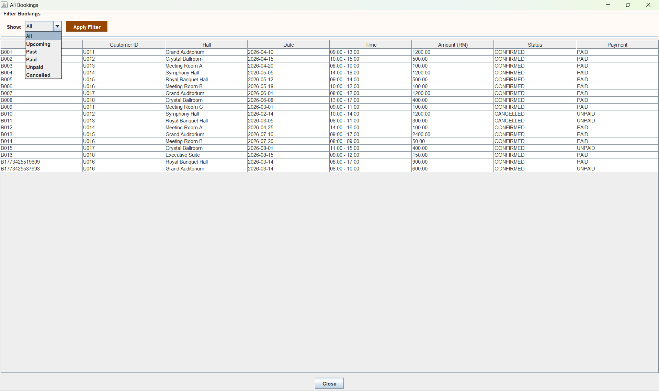
The admin will be able to view an exhaustive list of all bookings made across all customers, including booking ID, hall name, event date, status, and payment status.
Figure 31:
Generate Booking Report
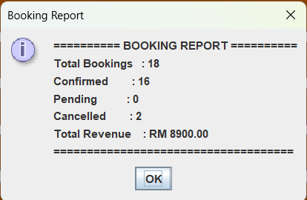
The Administrator is able to create a summary report to show the overall bookings and confirmed and canceled number of bookings and the total revenue that has been received as a result of the confirmed bookings.

Manager
Figure 32:
Manager Dashboard
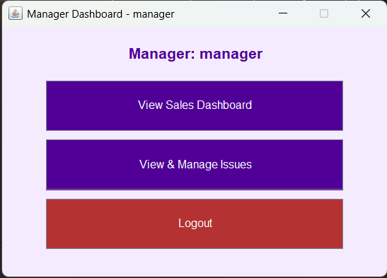
The manager dashboard will provide access to the sales dashboard as well as an issue management panel.
Figure 33:
View Sales Dashboard
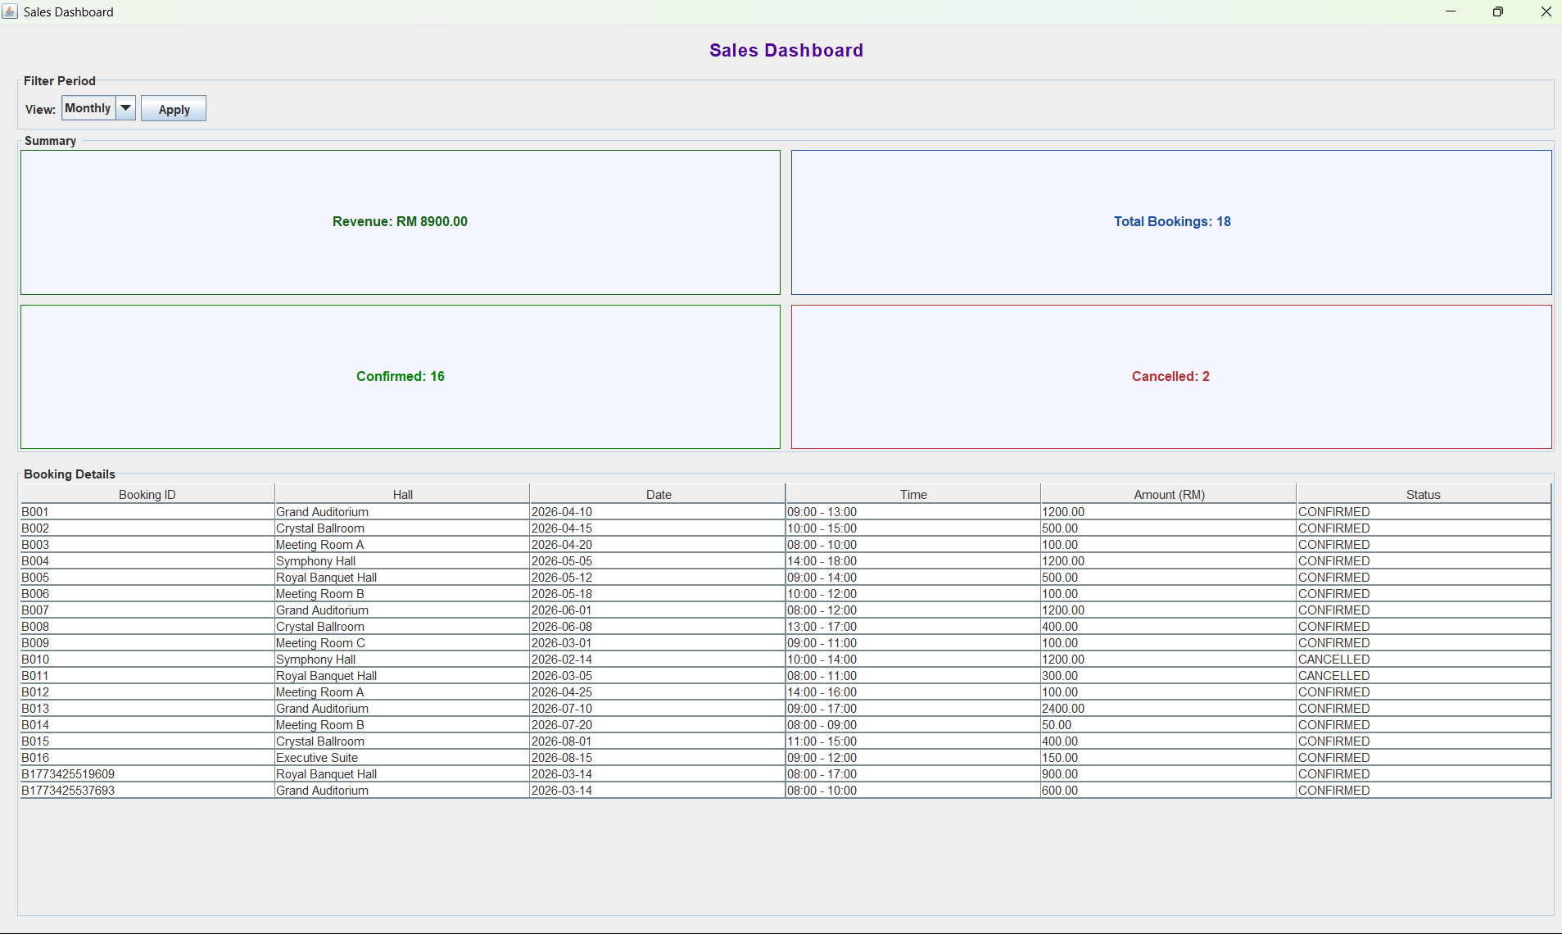
It will also indicate the booking revenue for the week/ month/ year so that the Manager can track business performance dynamics of hall bookings over time.
Figure 34:
View and Manage Issue
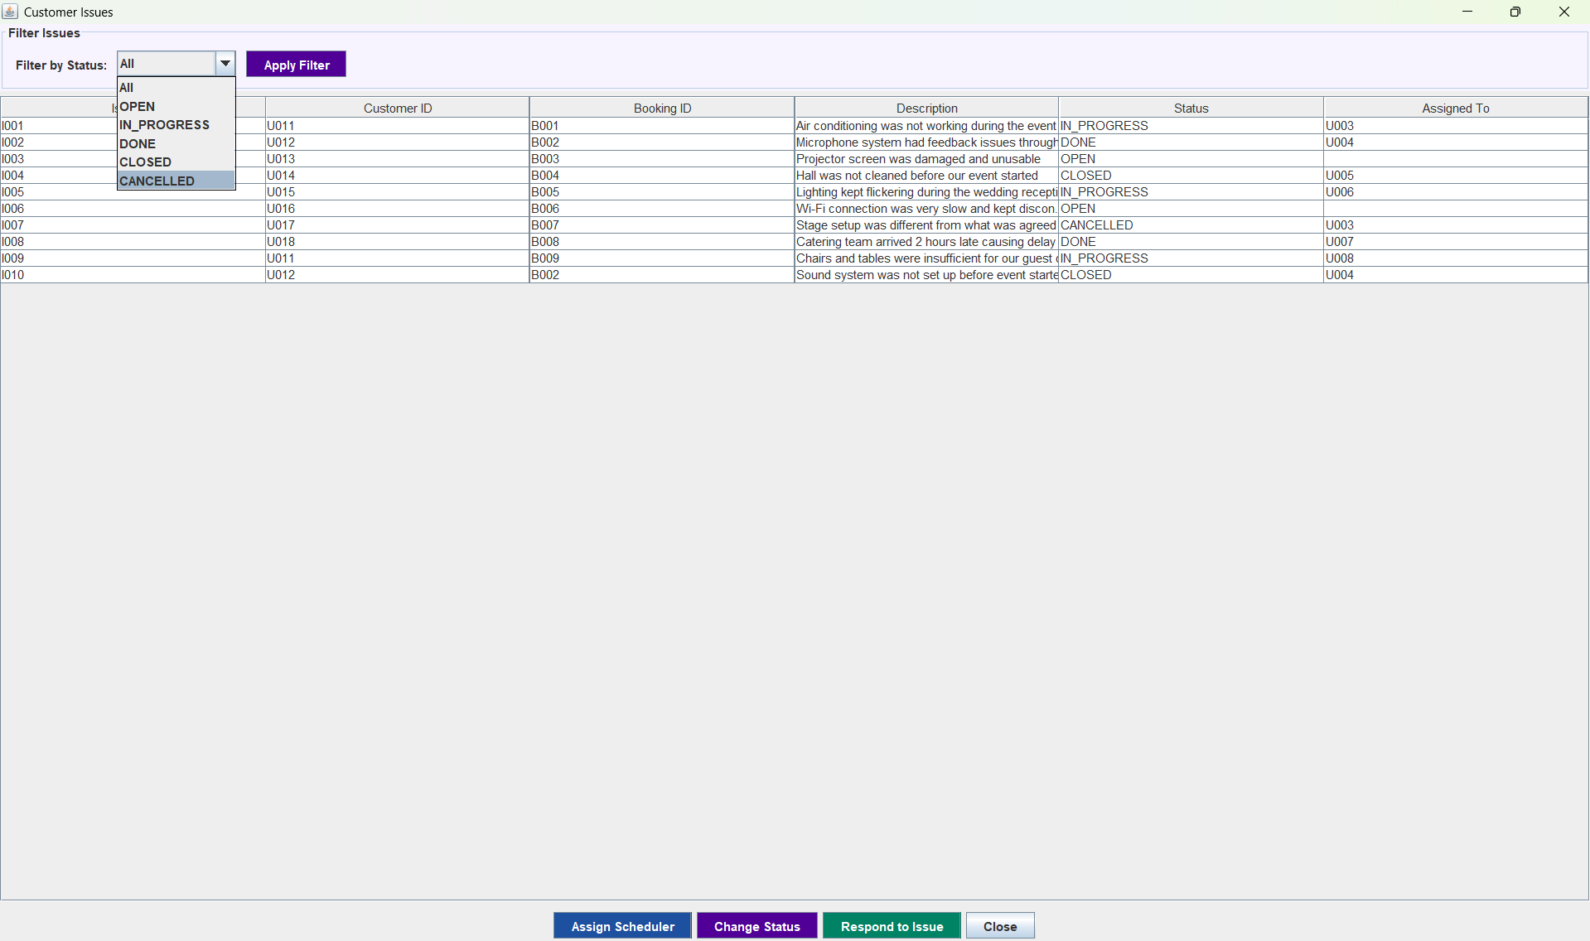
It will list down every issue raised by the customer until now along with its status. The manager is empowered to respond to any issues, assign a Scheduler for issue resolution, and change the status of the issue.

Scheduler
Figure 35:
Scheduler Dashboard
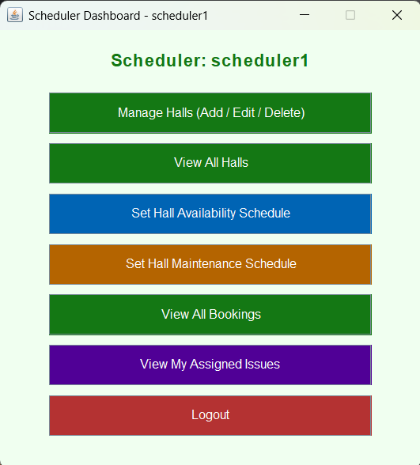
The Scheduler dashboard would feature the management of halls, the scheduling of availability, maintenance, and booking views along with the tracking of assigned issues.
Figure 36:
Manage Halls
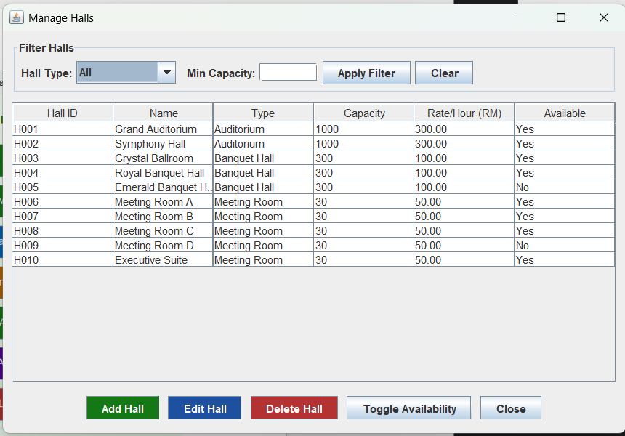
The Scheduler shall accommodate the addition of new halls, changing details like name, type, capacity, and rate of current halls, and deleting of halls from the system.
Figure 37:
View All Halls
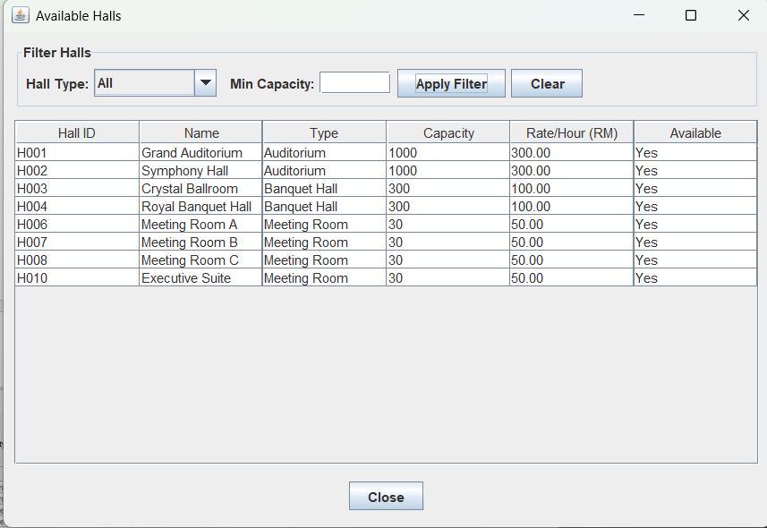
Represent the complete list of halls with its details in the system so that the Scheduler can review the hall information and availability status.
Figure 38:
Set Hall Availability
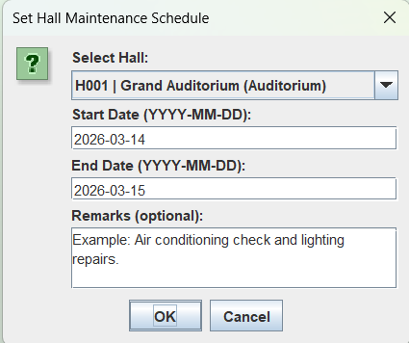
A Scheduler may determine a hall to be available to customers by specifying a start date and start time of day and end date and end time and optional remarks field.
Figure 39:
View All Booking
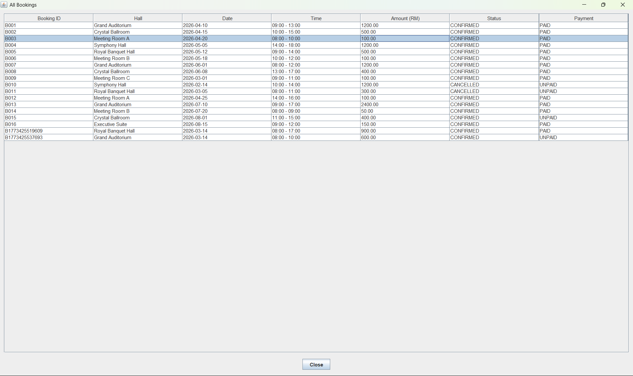
This empowers the Scheduler to view the complete list of all customer bookings across the system, ensuring the resolution of effective coordination among halls.
Figure 40:
View Assigned Issues
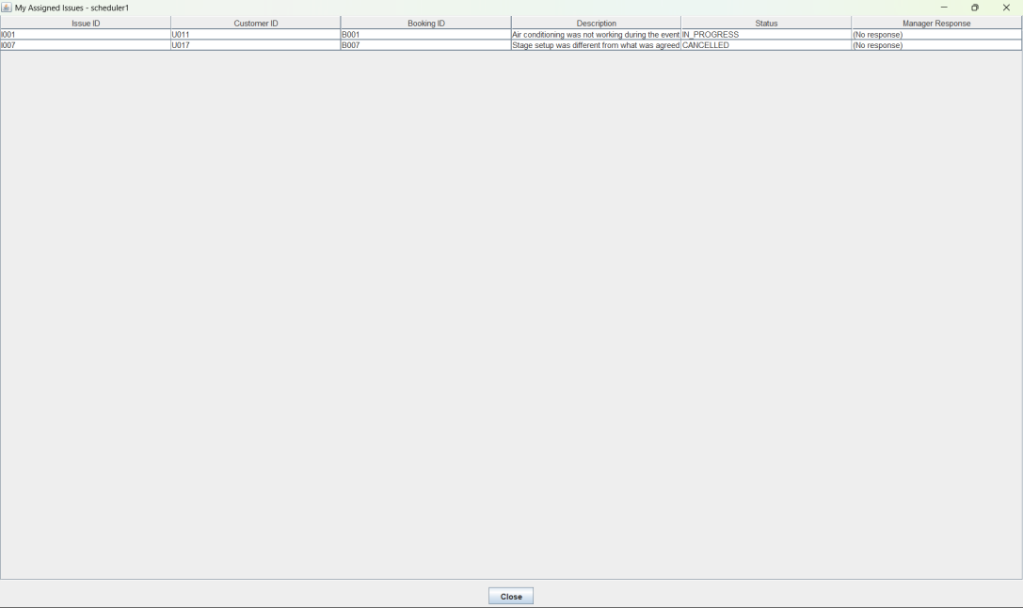
Shows all customer problems which have been sent to this Scheduler by the Manager. The Scheduler will be able to monitor the problems assigned to him/her, overview the description of the issue and the booking information, and address the problems accordingly.

Customer
Figure 41:
Customer Dashboard
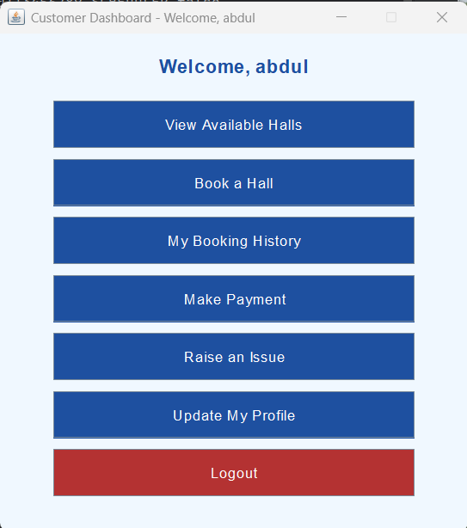
The Customer dashboard gives access to all customer features—halls, booking, payment, booking history, issue reporting, profile management.
Figure 42:
View Available Halls
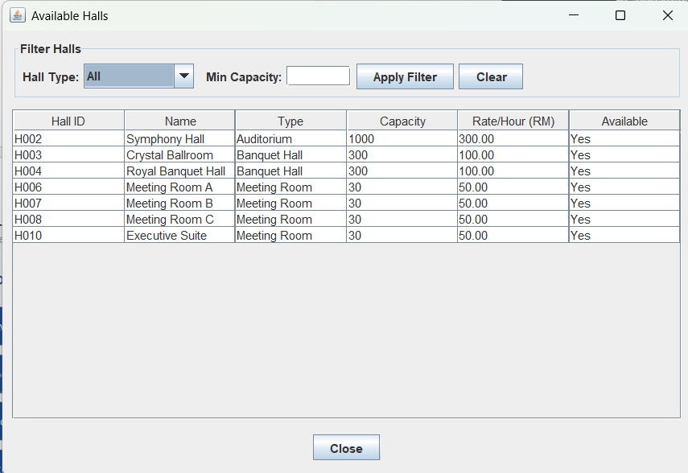
It provides an account of lit halls and their types, capacity, hourly rate. This is another important facility that the customer can avail of while choosing the halls.
Figure 43:
Book a Hall
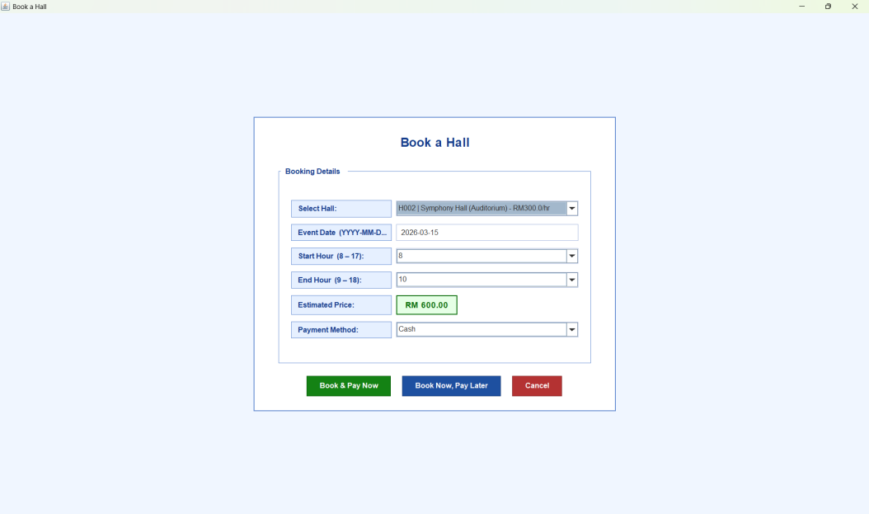
The customer shall be free to select a hall and then choose any event date and time within 8:00 AM to 6:00 PM, which slots into their event. Then they need to confirm the booking. Based on this, the system automatically calculates the total amount based on the hall's hourly rate and the duration of time for the event that he has chosen.
Figure 44:
View Booking History
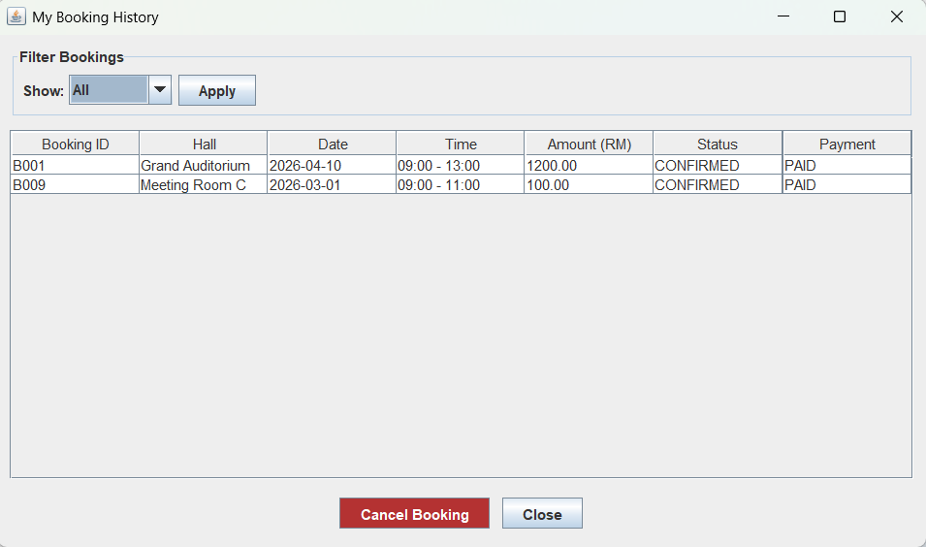
Displays all the future and previous bookings of a customer, booking ID, hall, event date, and time, total price, and status. On this screen, customer is able to filter and cancel bookings provided that they qualify.
Figure 45:
Make Payments
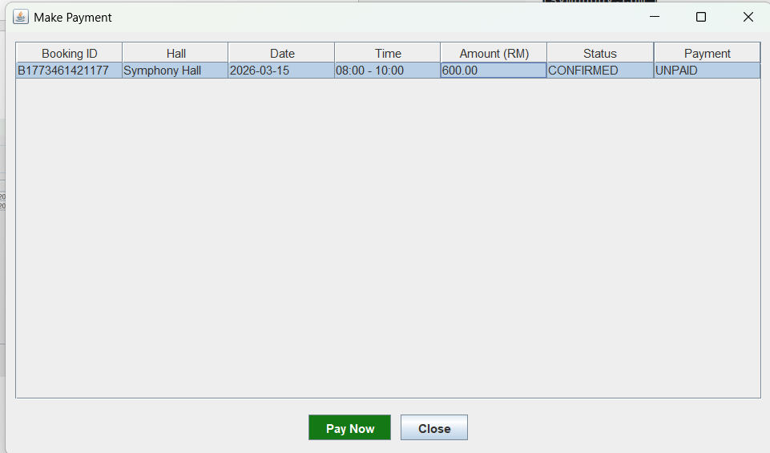
After ordering an unpaid booking, the customer will be required to choose one of the methods of payment, be it cash, card, or online transfer. The status of the booking will be changed to PAID with the help of booking confirmation.
Figure 46:
Raise Issue
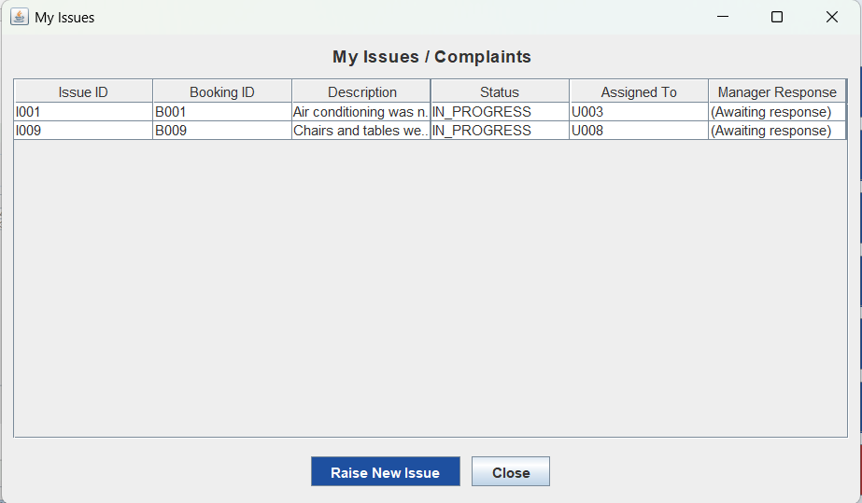
An issue is allowed to be raised by the customer against a particular booking. On issue raising, the manager will submit an OPEN status.
Figure 47:
Update Profile
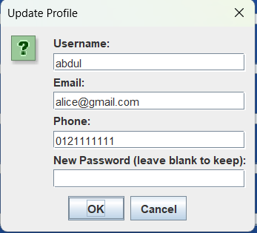
The customer updates their username, e-mail, phone number and password. The validation and bearing of the changes will be saved to users.txt, in real time.

Additional Features
The added additional features include the following:
- Booking Report by Administrator: This part of the system will show a report of all the booked events, the amount of confirmed and canceled bookings and the total revenue that the all the booked events earned. The application does not require leaving the report to provide a simple management summary.
- Auto-Seeded Default Accounts: In this approach initializeFiles() will determine whether users.txt is empty on the first start up; they will seed default Administrator account and Manager account to have the system up and running immediately ready to use without having to configure it manually.
- Several Payment Modes: The type of payment made in the Payment class allows three modes of payment: Cash, Card, Online Transfer. These have been outlined as constants: METHODCASH, METHODCARD, METHOD Online. In this manner, customers will be able to make a payment in different ways.
- Manager Response on Issue: In Issues class, the Manager Response field was added and this field is used to record the response of Manager directly to Customer issue other than assigning Scheduler and status change.
- Extended Issue Status Tracking: Issues has five statuses, namely OPEN, ASSIGNED, INPROGRESS, DONE, CLOSE, Cancel, which provide a level of issue status tracking that exceeds the limit.
- Timestamp-Based ID Generation: This is a technique that is used in FileManager.generateId, which is based on the System.currentTimeMillis() to come up with unique IDs that would be unique to all entities in order to prevent potential ID conflicts among users, bookings, payments, as well as issues among others.
- Color-Coded Dashboards: Visually every role home page is distinguished by a unique collection of colors; blue Customer, green Scheduler, orange Administrator etc. The immediate visual segregation is done by the administration of all color-coded dashboards on each role.
- Input Checks: Empty fields, duplicate user names, invalid formats will all be checked. The system also has nice JOptionPane error dialogs to take the user through in case of validation failure (JetBrains, 2024).

Limitations and Conclusion

Limitations
The following are some of the limitations of the system:
- Plain Text Stories dangers: The data files have not been written in a transactional way and thus in case of a crash during writings, the file can be corrupted.
- Password Encryption: The passwords are simply stored in the users.txt file. In a production system, it would be expected that BCrypt or another hash algorithm that is strong is used to secure the user credentials.
- Booking Conflict Detection: The system can provide two customers to book at the same hall at the same time as there is no logic that would be used to execute and check whether the time slot is already booked upon booking.
- It does not support concurrent access: The number of instances accessing at the same time may cause a race condition on the shared .txt files, potentially resulting in a possible data loss or corruption otherwise.
- Limited Reporting: Sales dashboard of the manager provides easy revenue summaries and lacks export to PDF and Excel and presentation of the charts to support trend analysis.
- No Email Notifications: In live case, customers must be informed through email about their booking, payment or reporting the issues (Oracle Corporation, 2024).

Conclusion
This case study of a complete operation Java GUI application that illustrates all the four OOP principles: encapsulation, inheritance, polymorphism and abstraction was coded using Hall Booking Management System. Next, it also has a hierarchy of classes the top one being an abstract class User to prevent any duplication between the four user roles and offers a tidy and very extensible framework. Another utility class is named as FileManager which handles a well abstracted data layer hence enabling the GUI code to be fully independent of the storage mechanism. The additional functionality that would monitor the problems within a much more sophisticated tracking system where a manager can respond to them was also fully covered. It even featured over a single way of payment and has auto-seeding of default account in the interest of usability and strength of the project. Thus, it has fulfilled its goal since it has developed and deployed an Object-Oriented System in Java.

References
Bloch, J. (2018). Effective Java. Addison-Wesley.
Deitel, P., & Deitel, Harvey. (2020). Java: How to Program, Early Objects. Pearson.
geeksforgeeks. (2026, March 9). Abstraction in Java. Retrieved from geeksforgeeks: https://www.geeksforgeeks.org/java/abstraction-in-java-2/
geeksforgeeks. (2026, March 7). Encapsulation in Java. Retrieved from geeksforgeeks: https://www.geeksforgeeks.org/java/encapsulation-in-java/
geeksforgeeks. (2026, March 9). Inheritance in Java. Retrieved from geeksforgeeks: https://www.geeksforgeeks.org/java/inheritance-in-java/
geeksforgeeks. (2026, March 9). Polymorphism in Java. Retrieved from geeksforgeeks: https://www.geeksforgeeks.org/java/polymorphism-in-java/
JetBrains. (2024). IntelliJ IDEA: The Java IDE for Professional Developers. Retrieved from JetBrains.
Oracle Corporation. (2024). Java SE 8 Documentation. Retrieved from Oracle.
Oracle Corporation. (2024). Java Swing Tutorial. Retrieved from Oracle.

Appendix – Text File Screenshots

Appendix A - users.txt
It carries details of all user accounts that are created in any role.
Form: userid, user name, password, email address, phone number, role, blocked.
Figure 48:
User.txt
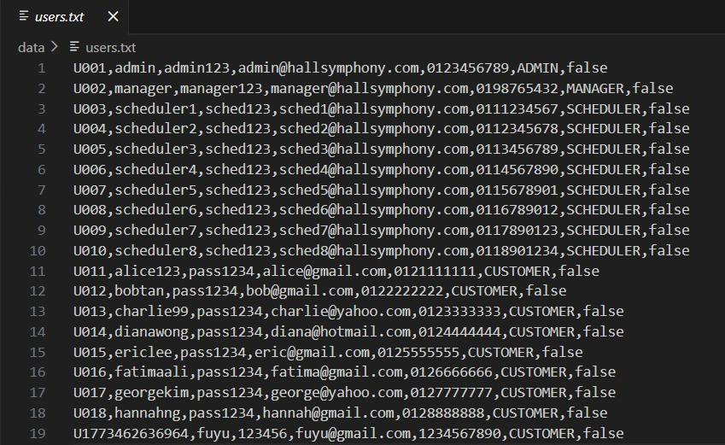

Appendix B - halls.txt
It holds all the hall records that are entered by the Scheduler.
Form: hallID, hallname, halltype and capacity, per hour rate, availability.
Figure 49:
Halls.txt
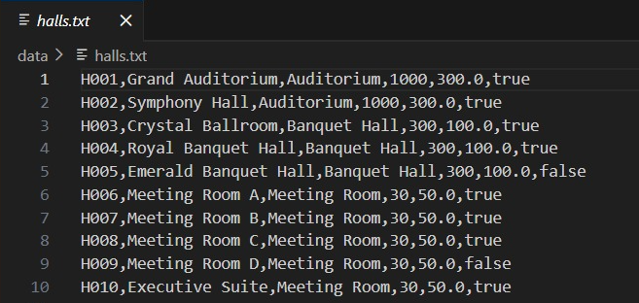

Appendix C - bookings.txt
Holds information about all bookings done by the customers.
Form: bookingID, customerID, hallID, hall name, the event date, hours of starting and hours of ending, total price, state, and payment status.
Figure 50:
Bookings.txt
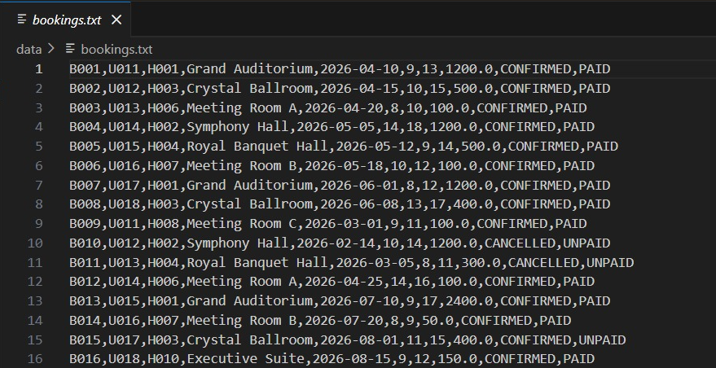

Appendix D - payments.txt
It keeps all payment records related to bookings.
Form: paymentId, bookingId, and amount, paymentmethod, paymentdate.
Figure 51:
Payments.txt
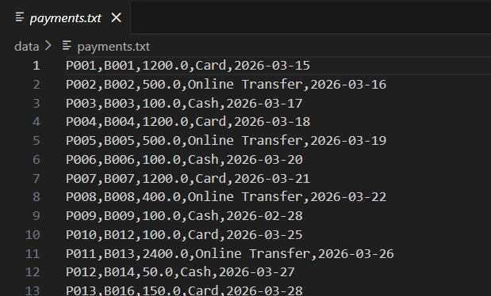

Appendix E - issues.txt
Holds all issues raised by the customer and their status.
Form: IssueId, customerID, bookingId, description, status, assignedSchedulerId, manageResponse.
Figure 52:
Issue.txt
